**India in 2020:**

Making Changes

**-Charvi Jain, Hindu College**

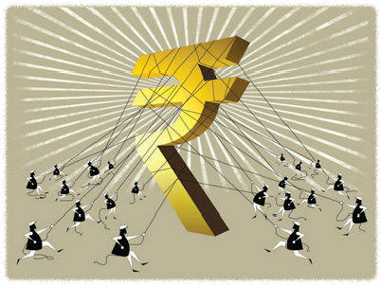

We’ve been mixing black and white

While trying our best to pick a side

We’ve been firing shots at night

In a fancy stadium with no lights

We’ve been taking power rides

While trying to get our air kicks right

We’ve been bragging about our might

Advising our enemies to run and hide

A corrupt matador is in sight

An unemployed Cyclops prepared to fight

It is best to fasten our seat belts tight

Hoping to remember our well-rehearsed lines

If I ever travel through time

My heart hopes to find

Some spotlight shed on equal rights

With our economy climbing new heights

I can see people stopping to stare

At the shattered glass of a fake fair

Instead of warming up, I believe

We’ll be putting up a fight to alter the society.

